

**Dr. D Y Patil Unitech Society, Pune**

Dr. d. y. Patil arts, commerce & science college

Pimpri, pune – 411018

A

Project Report On

“ PLATES OF FLAVOURS”

***Developed by***

**Alex D’souza**

**Apurva Jambhale**

**Pooja Kulkarni**

**2020 – 2021**



**Dr. D Y Patil Unitech Society Pune**

Dr. d. y. Patil arts, commerce & science college

Pimpri, PUNE – 411018

DEPARTMENT OF COMPUTER SCIENCE

CERTIFICATE

Exam Seat No:- Date:-

This is to certify that the project entitled **“Plates of Flavours”** is completed by **Mr. Alex .Augustin. D’souza** Students of  **DR. D. Y. PATIL ARTS, COMMERECE & SCIENCE COLLEGE, PIMPRI** in fulfilment of M.Sc.(COMPUTER SCIENCE) Project Work in academic year 2020-2021. This is the record of work carried out by them.

**Project Guide Head of Department**

**External Examiner Internal Examiner**

**Acknowledgement**

We would like to express my special thanks of gratitude to our Project guide **'Mrs. SONALI NEMADE’** as well as our H.O.D & Vice Principal **Dr. Ranjit Patil** sir who gave me the golden opportunity to do this wonderful project on the topic “**Plates of Flavours**”, which also helped me in doing a lot Research and I came to know about so many new things I am really thankful to them.

Secondly, I would also like to thank guardian and friends who helped me a lot in finalizing this project within the limited time frame.

We are thankful to all fortunate enough to get constant encouragement, support and guidance from all teaching staff of **Department of Computer Science** which helped successfully our project work. Also, we would like to thanks our friends for their help.

Yours Sincerely,

Name: Alex .A. D’souza

**INDEX**

1. Certificate
2. Acknowledgement
3. Index
4. Existing System
5. Proposed System
6. Scope of the System
7. H/W and S/W Requirements
8. Fact Finding Techniques
9. Diagram
10. Class Diagram
11. Usecase Diagram
12. Sequence Diagram
13. Activity Diagram
14. Collaboration Diagram
15. Testing
16. I/O Screen
17. Conclusion
18. Future Enhancement
19. Bibliography

EXISTING SYSTEM

In the present scenario, people have to physically visit the hotels or restaurants for eating food and have to make payment through cash mode.

In this method time as well as physical work is required also traditional food ordering procedure is not efficient enough for hotels and restaurants, as they have to deal with the crowd in there hotel.

The old methods can be classified into categories which are paper grounded and verbal grounded. For paper based work, the waiter comes and pens down foods that customers order and pass the food list then chef cooks in the further process.

Also from owners point of view maintaining data record and the account in physical file are tedious work to do. Also it is full of risk as anyone can access it and modify the data.

PROPOSED SYSTEM

This system is a bunch of benefits from various point of views. As this online website enables the end users to register to system online, select food item of their choice from menu list and order food online.

The payment can be made through online mode or at the time of delivery depending upon the customers choice and convenience. One of the various benefits of this is system is that is there is rush or huge crowd present in the restaurant then in that case sometimes availability of tables cut downs the restaurants customer with this system work load of waiters in the restaurants are reduced. This system allow the staff to serve customer within less time as compared to the manual system.

SCOPE OF THE SYSTEM

This system includes: Billing, Inventory, Website, and Reservation. This system will change the manual system of the business in order for the user to work easier and provide faster transaction for the customer. It can produce an accurate and reliable report which includes print-outs of receipt for customer’s payment and inventory of menu’s, beverages, etc. The system will only be manipulated by the authorized person like the owner.

H/W AND S/W REQUIREMENTS

**HARDWARE REQUIREMENTS-**

1) RAM-2GB

2) PROCESSOR-Intel Dual Core/i3/i5/i7…

3) HARD DISK-Minimum 4 GB

**SOFTWARE REQUIREMENTS-**

1)OPERATING SYSTEM-Windows XP/Windows 7/Linux/Unix

WEB TECHNOLOGIES –HTML5, CSS

OTHER REQUIREMENTS – GITHUB, BOOTSTRAP

PLATFORM –ANY

FACT FINDING TECHNIQUES

1. Sampling of existing documentation forms, and commands.
2. Questionnaires.
3. Testing the code by implementing it.
4. Fact finding used throughout the commands application life cycle, crucial to the early stages including commands planning, system definition and requirements collection and analysis stages.
5. Enables us to learn about problems, opportunities constraints, requirements and priorities.
6. In our command we have normally used fact finding techniques during a single project.
   * + - * Examing the code.
         * Observing the output.
         * Research.

DIAGRAMS

**CLASS DIAGRAM**

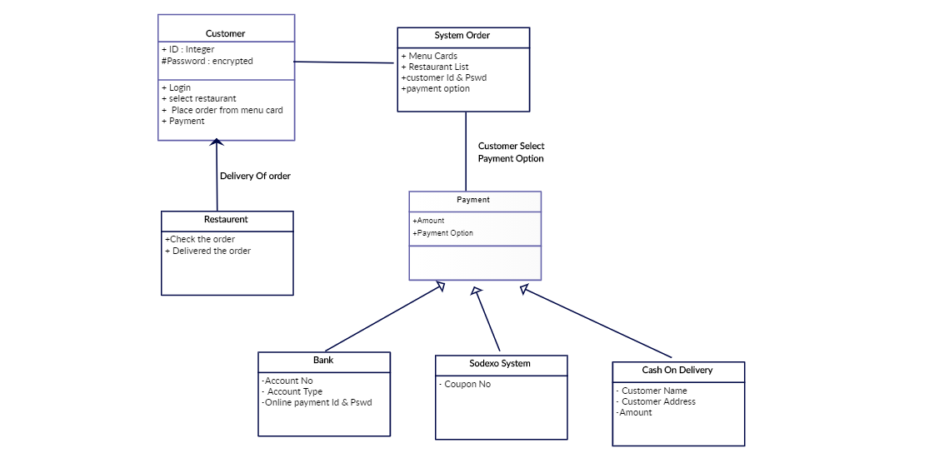

**USECASE DIAGRAM**

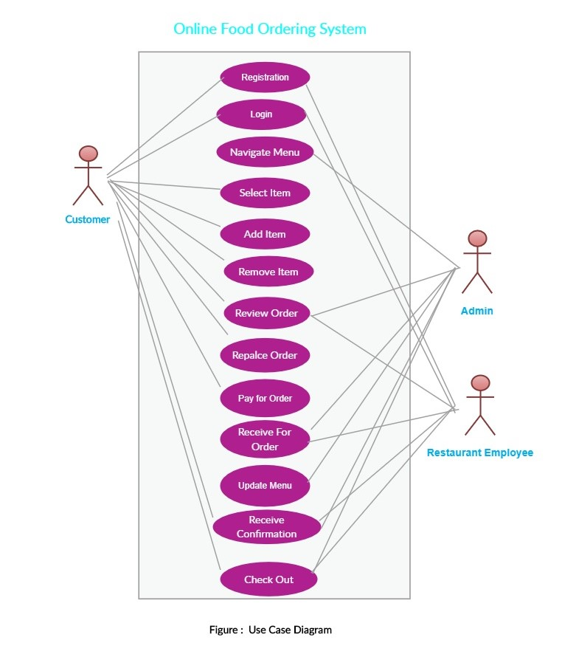

**SEQUENCE DIAGRAM**

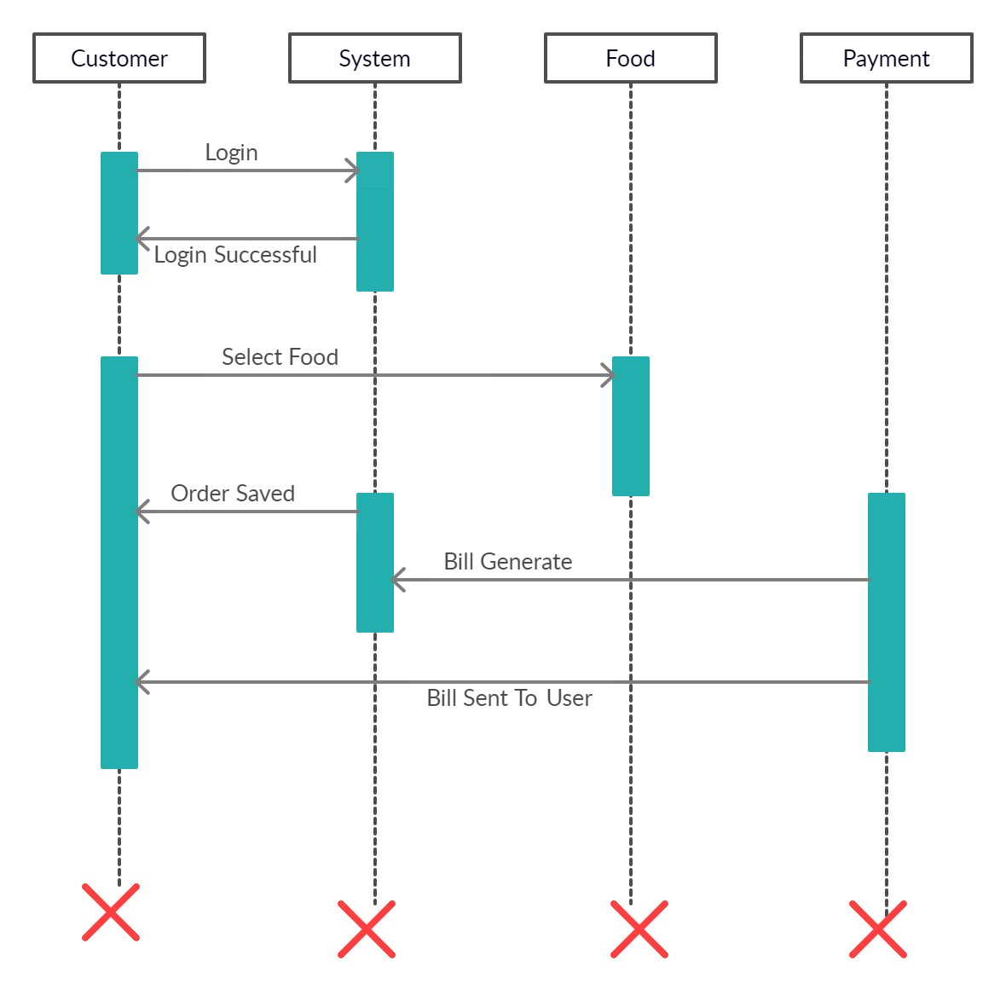

**COLLABORATION DIAGRAM**

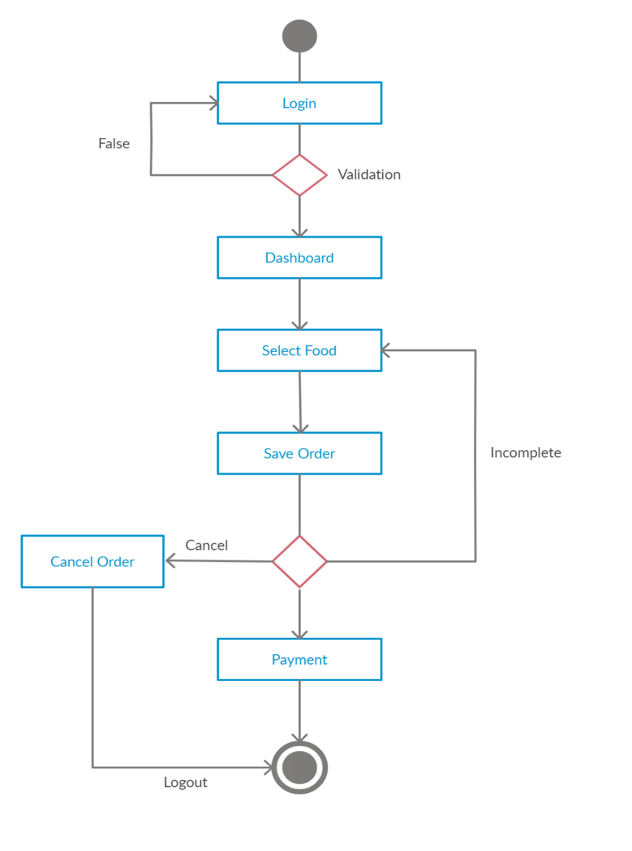

TESTING

|  |  |  |
| --- | --- | --- |
| **Test data** | **Expected Output** | **Actual output** |
| Commit changes made in the code. | Will commit the changes in the file. | Commit the changes. |

|  |  |  |
| --- | --- | --- |
| **Test data** | **Expected Output** | **Actual output** |
| Push date. | Push all files to the repository. | Push and upload the file to the repository. |

|  |  |  |
| --- | --- | --- |
| **Test data** | **Expected Output** | **Actual output** |
| Use git pages. | Host the site in git pages. | The site will be deployed. |

I/O SCREENS

**INPUT SCREENS**

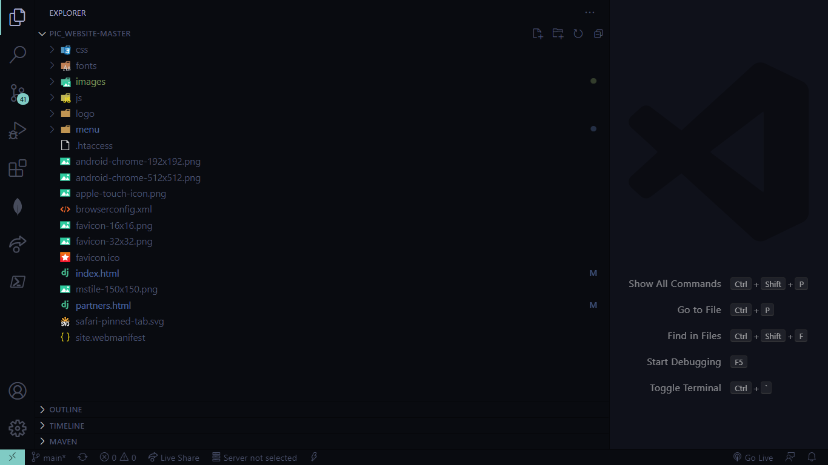

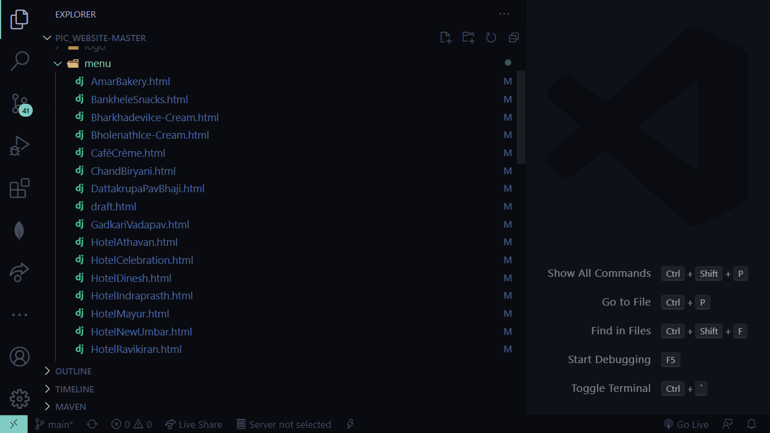

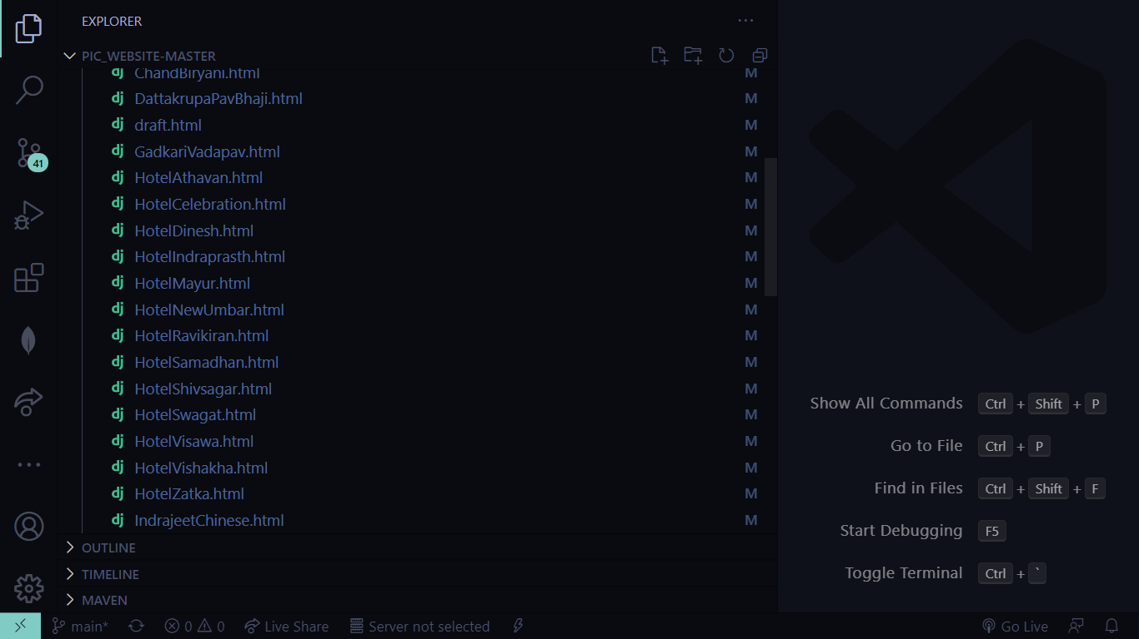

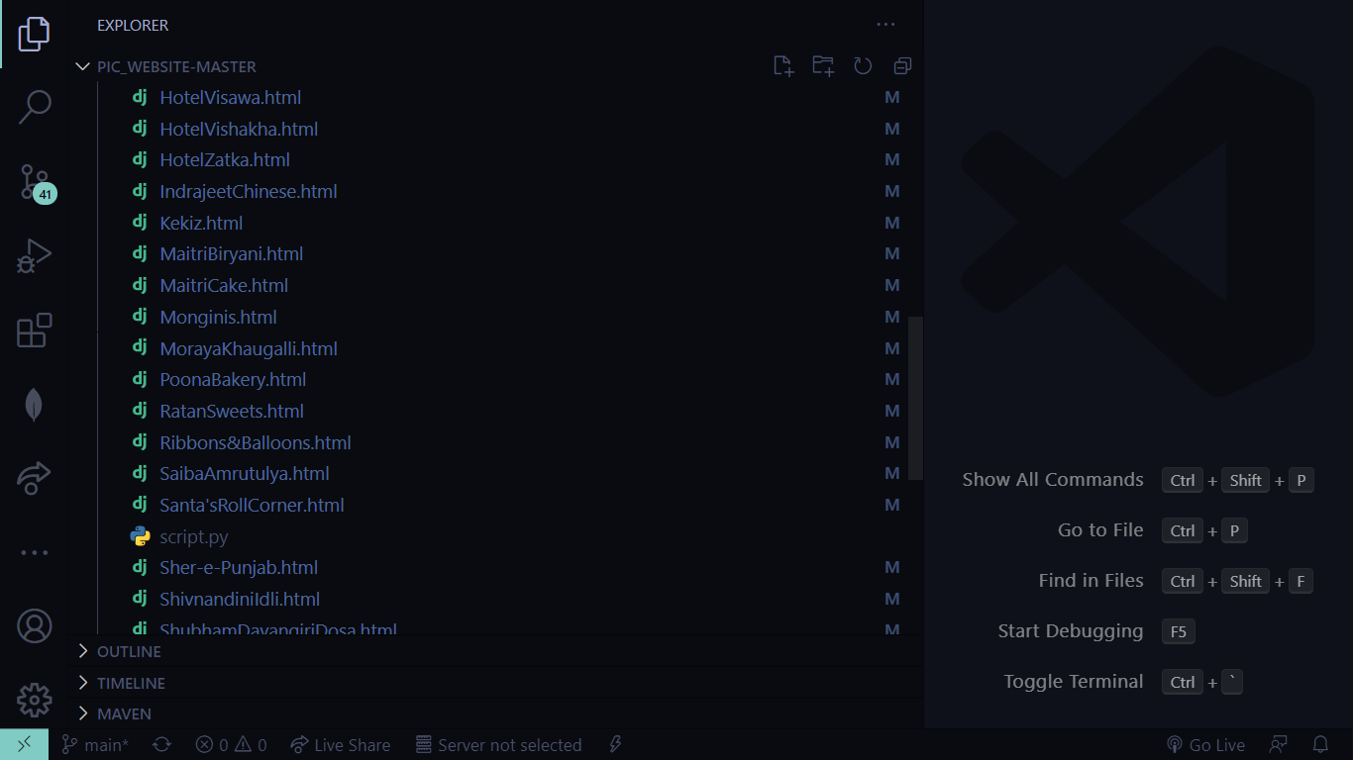

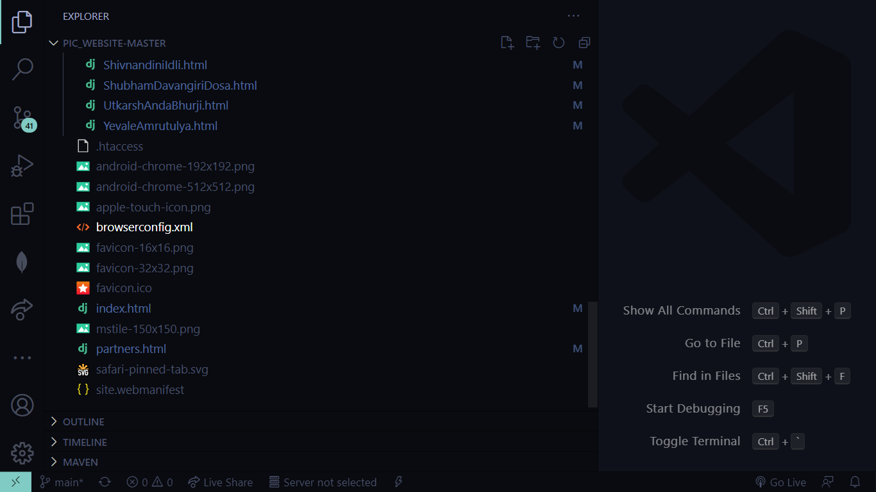

**INDEX.HTML**

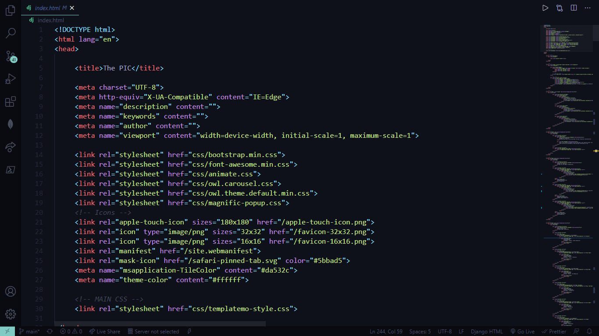

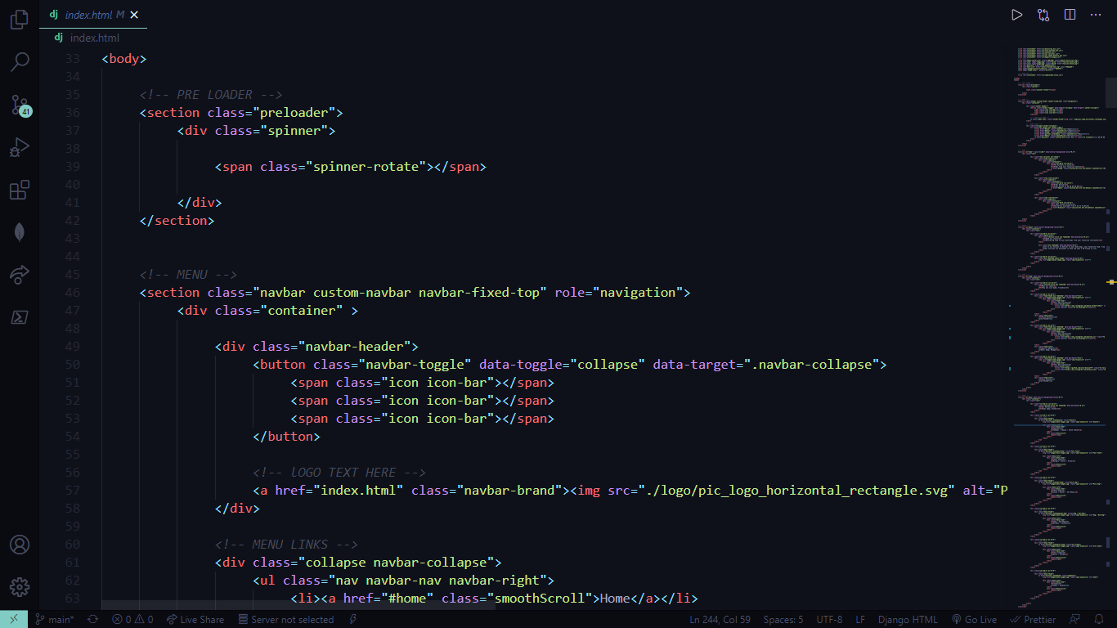

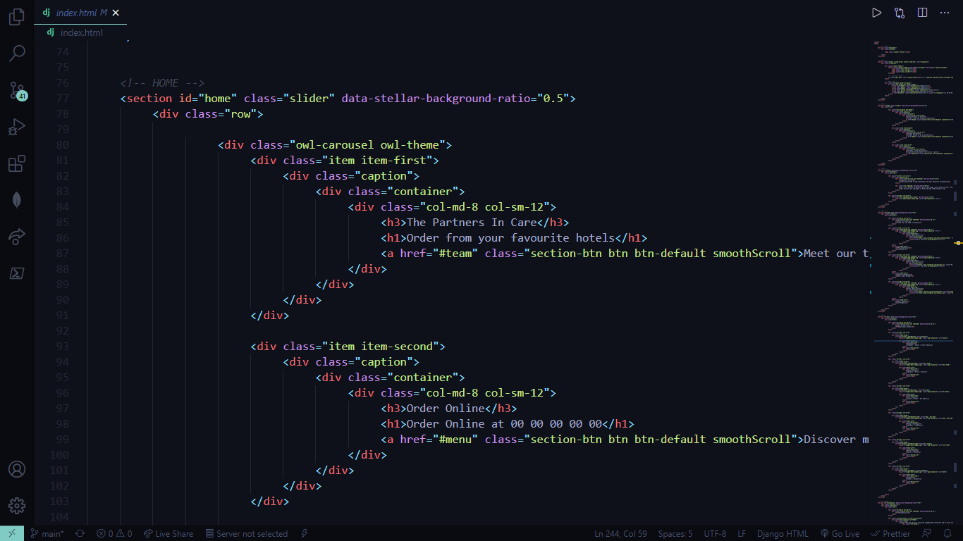

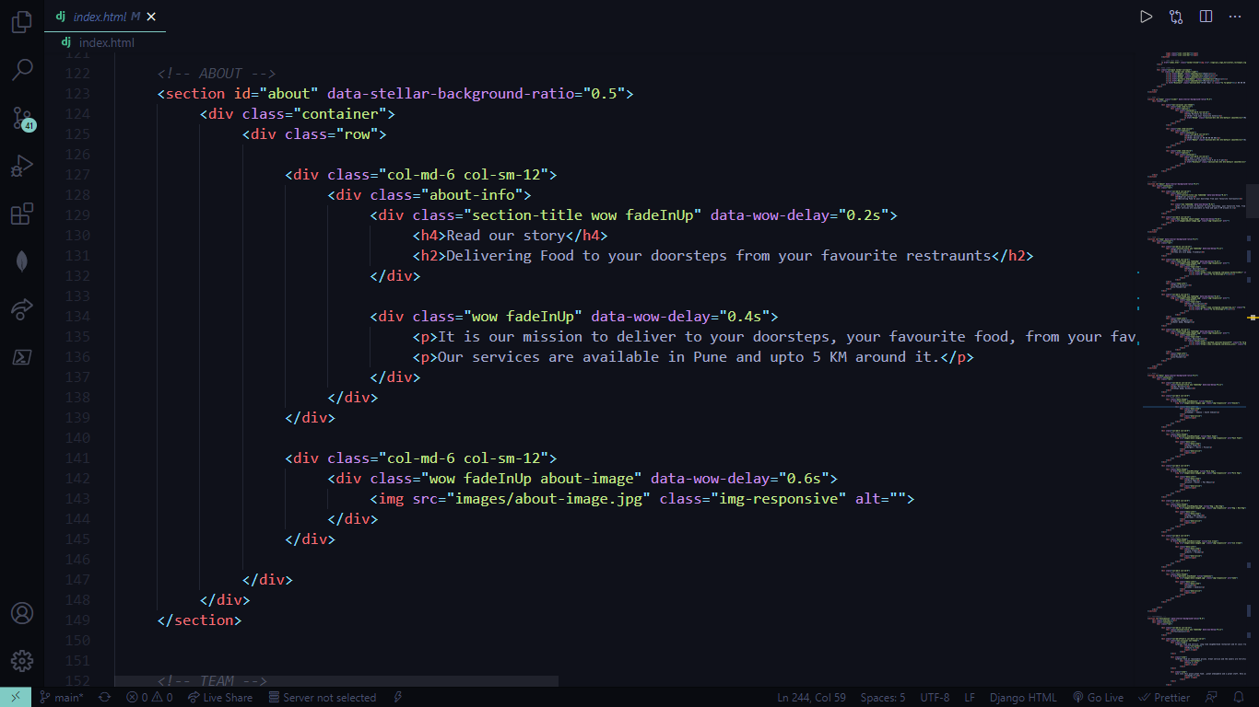

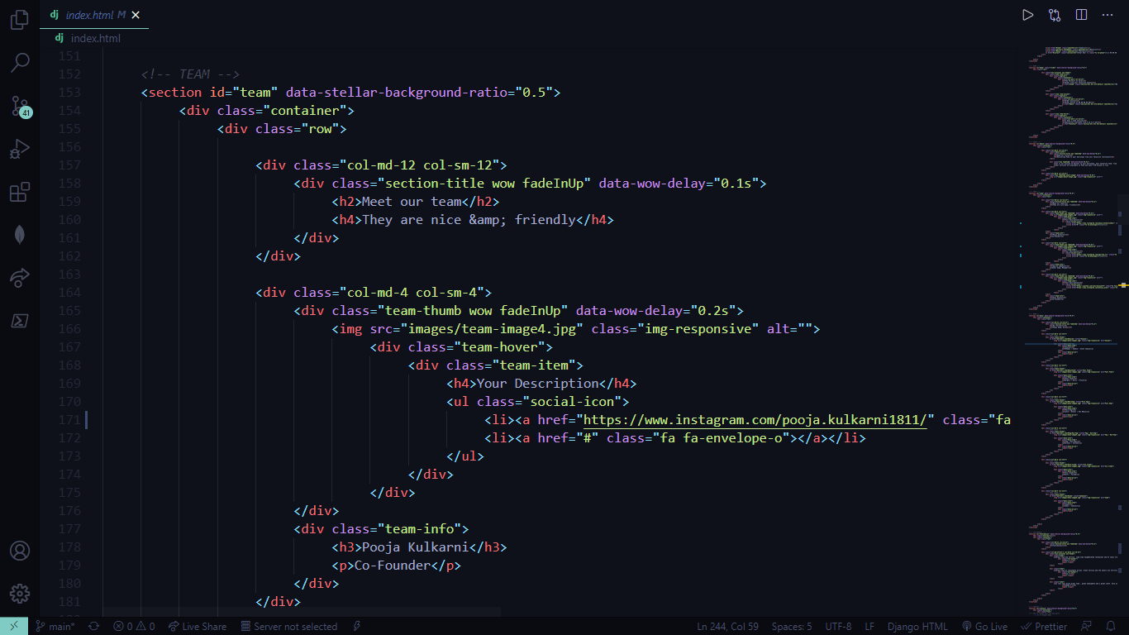

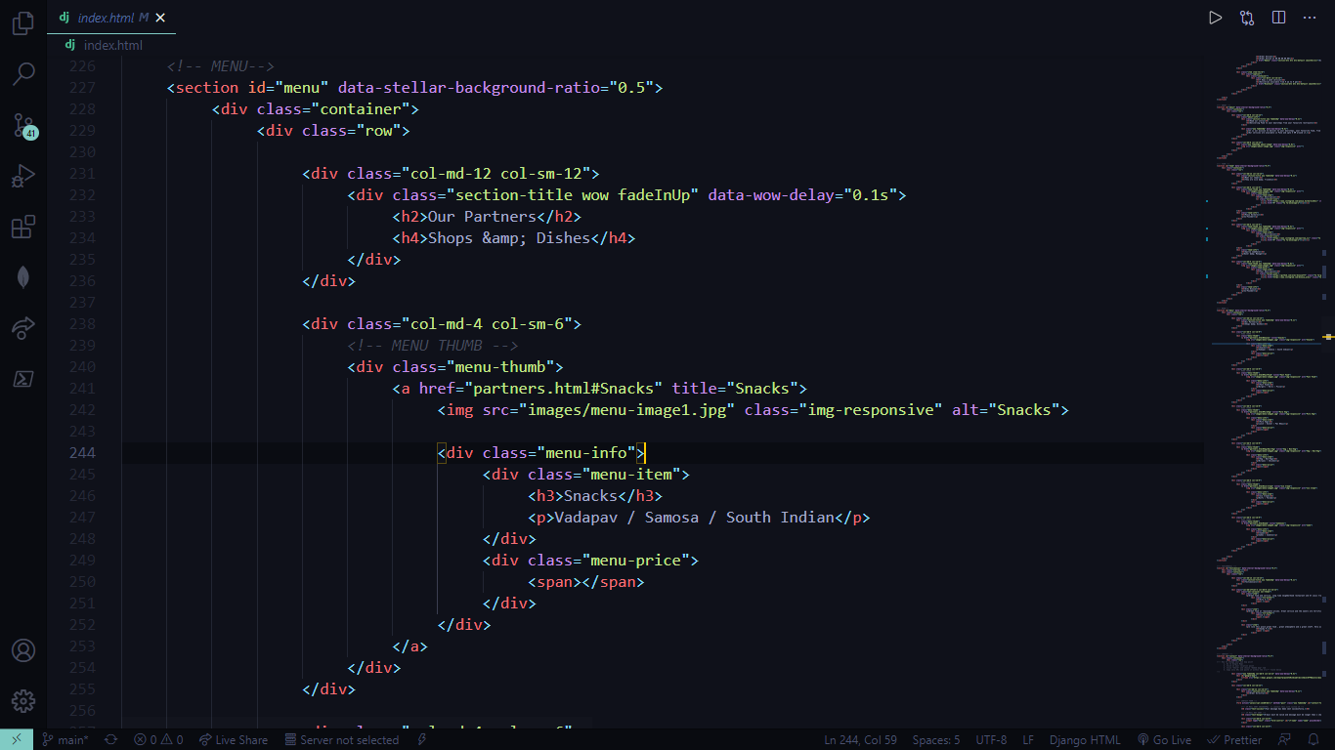

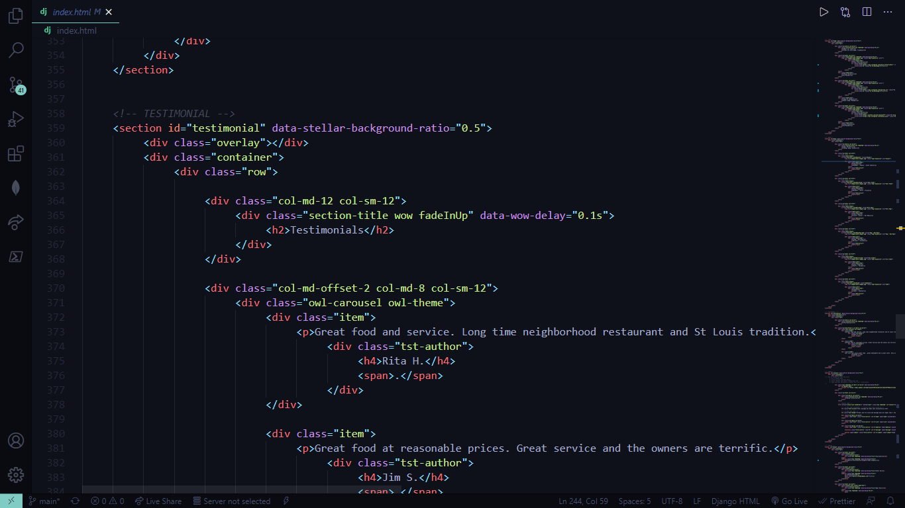

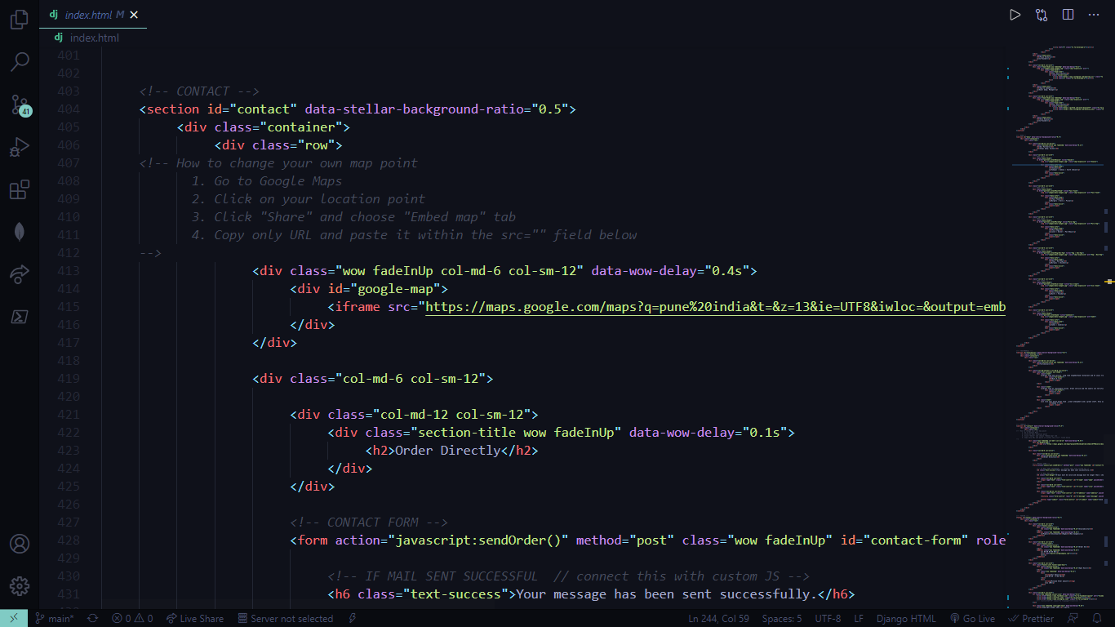

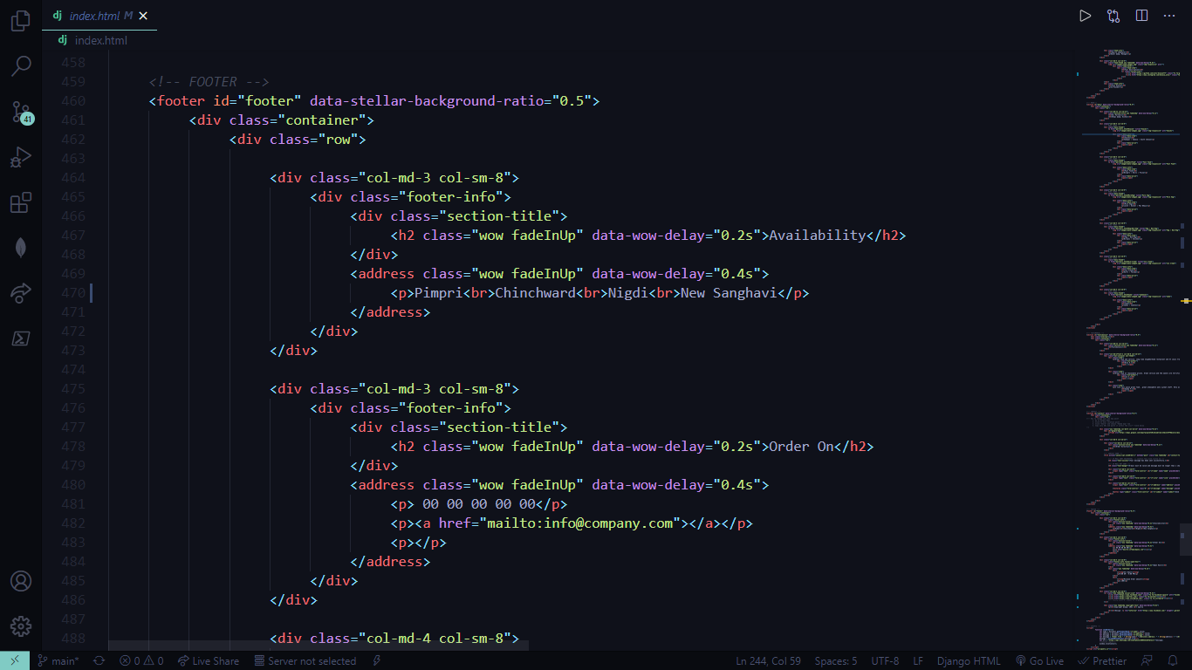

**OUTPUT SCREENS**

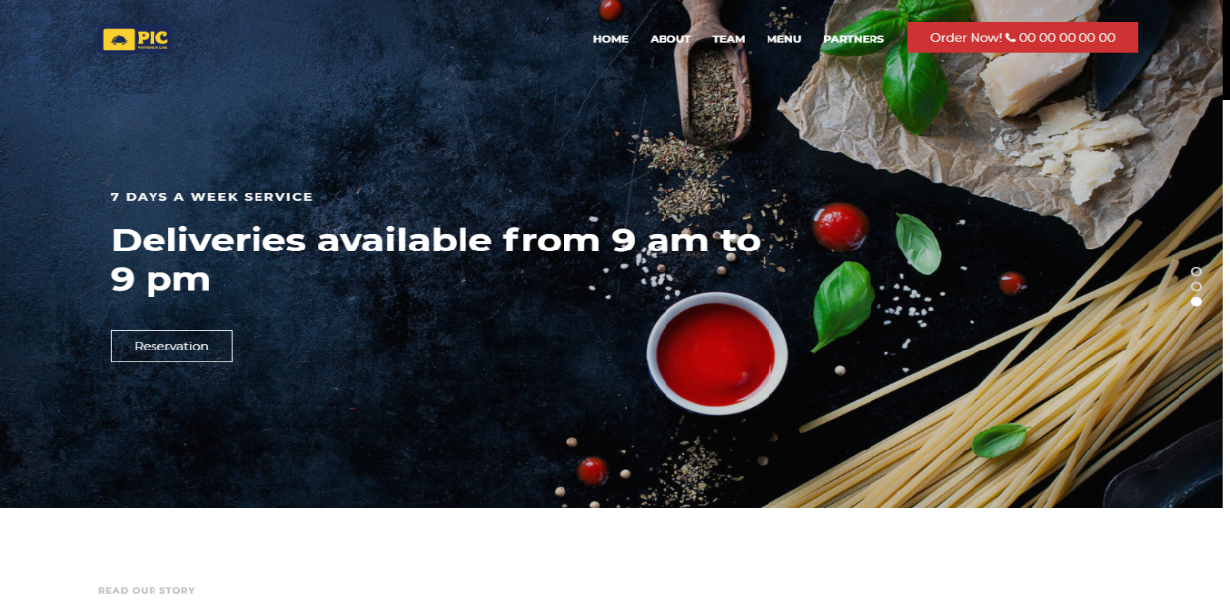

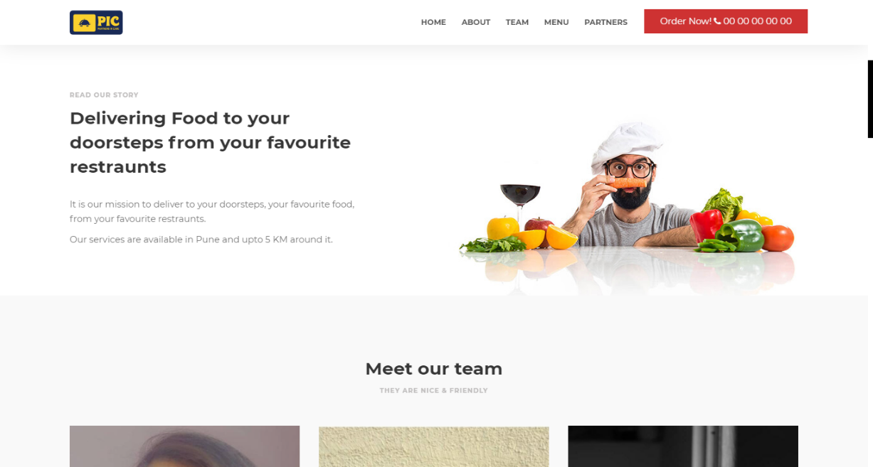

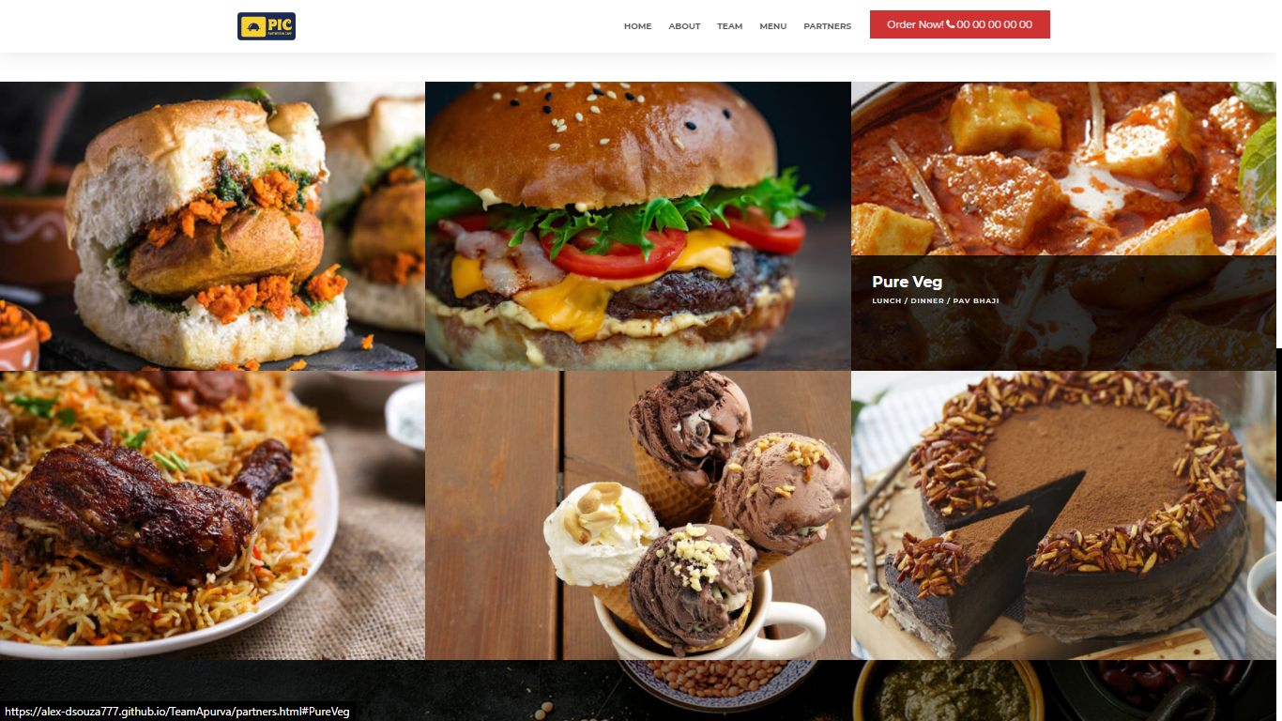

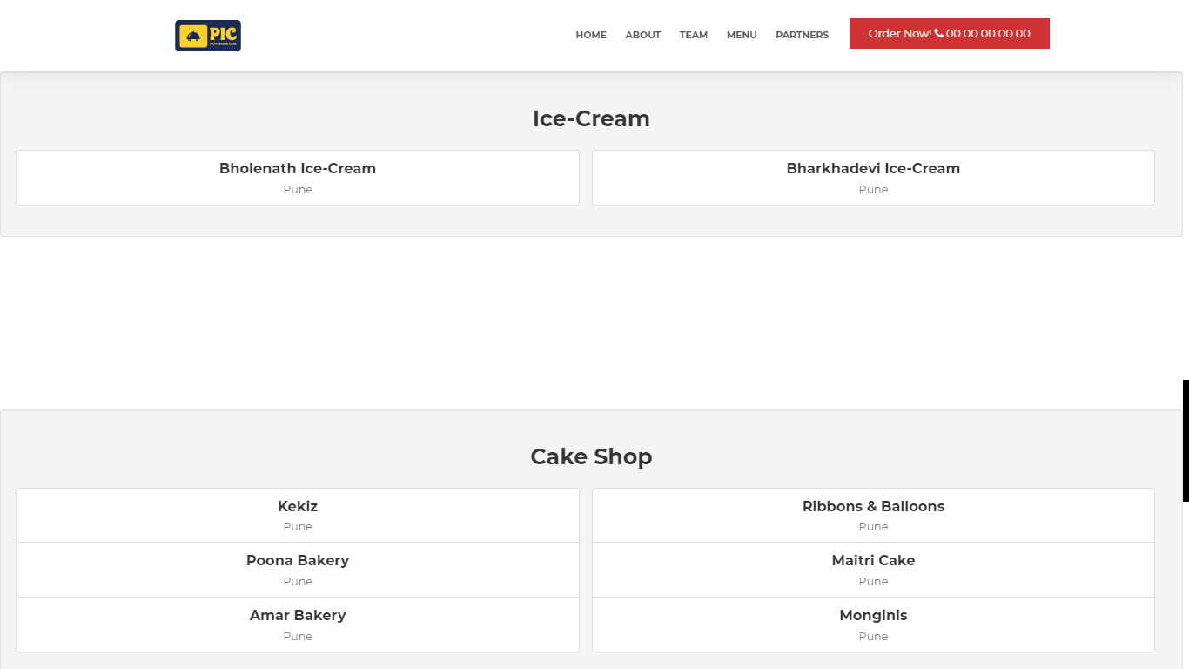

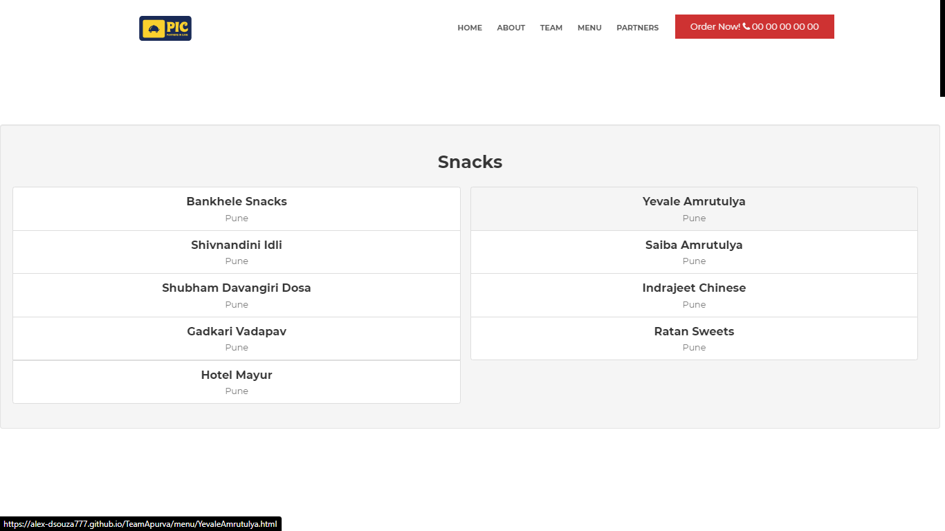

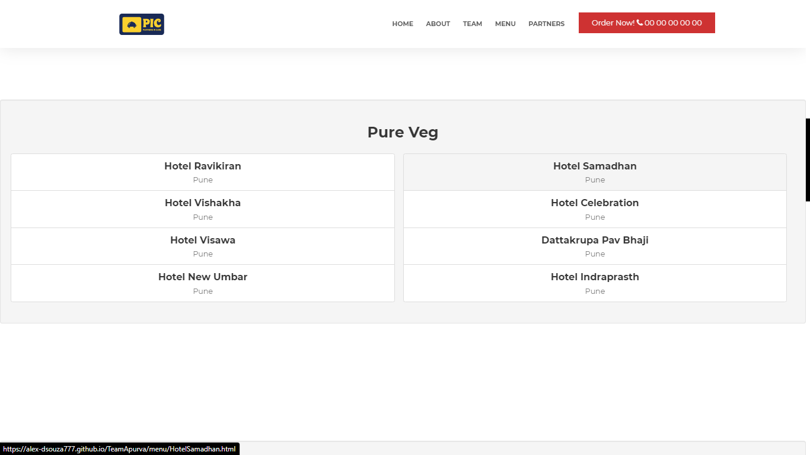

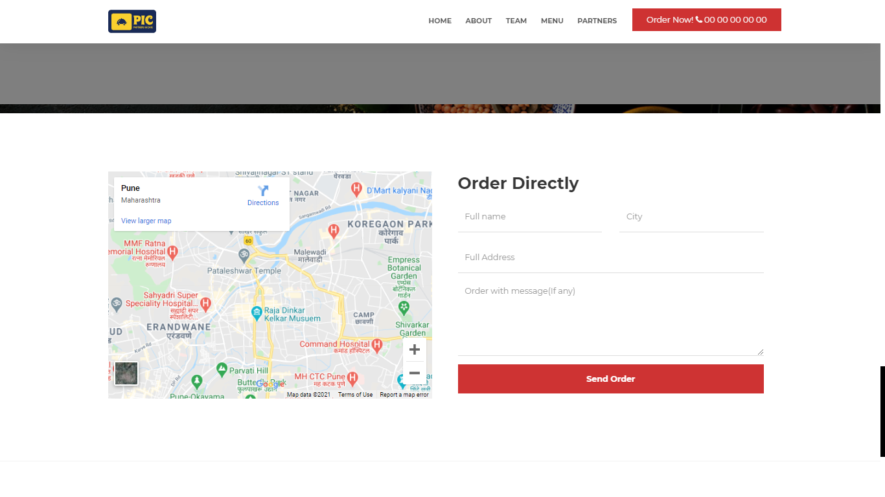

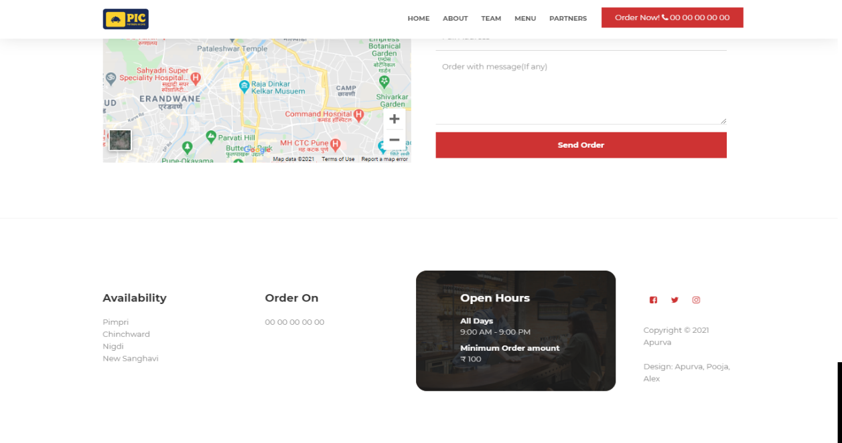

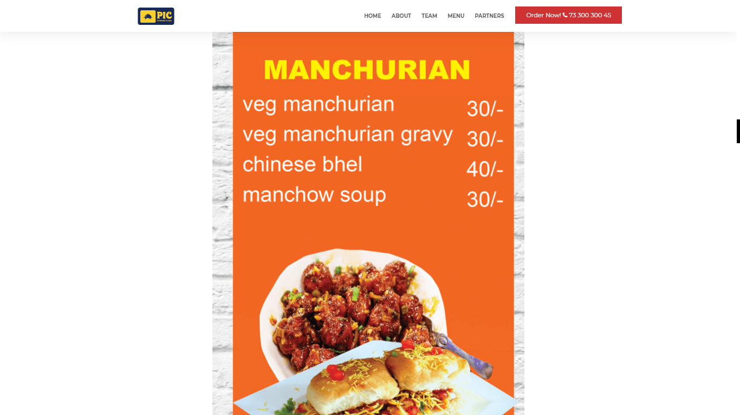

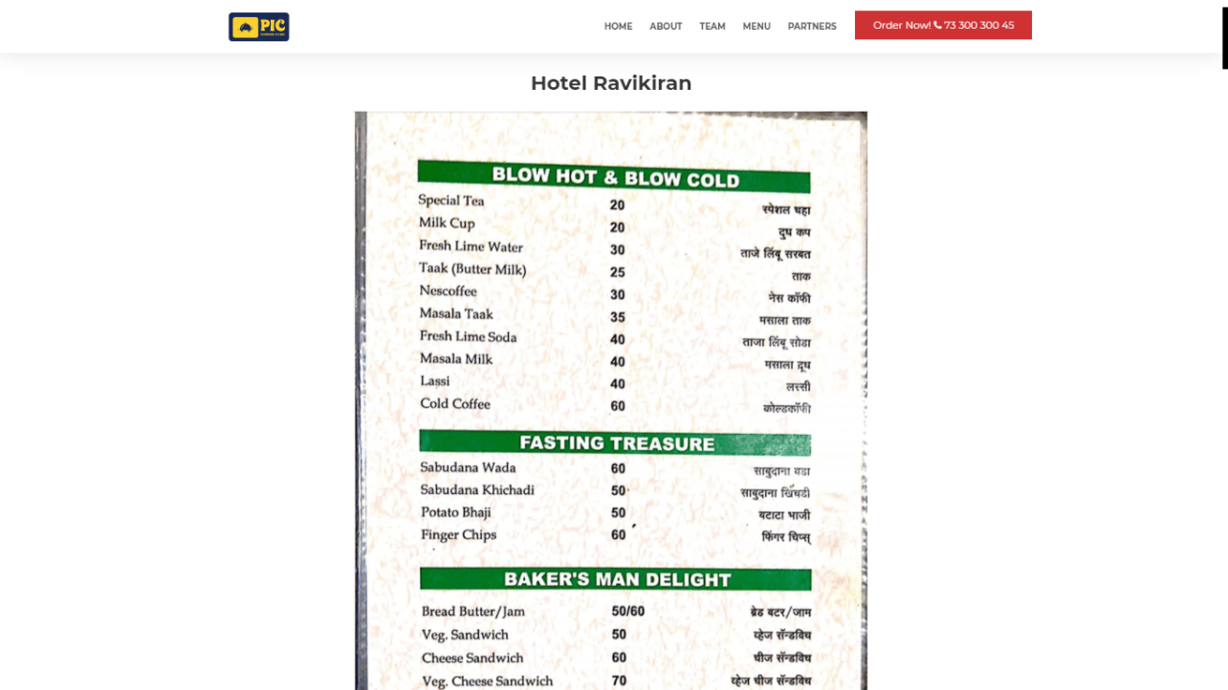

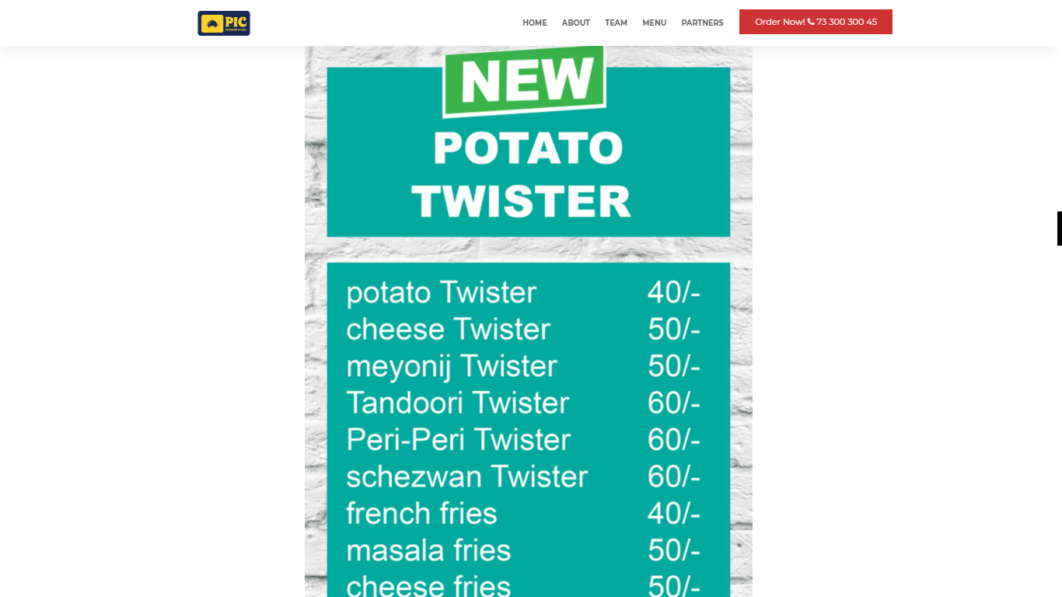

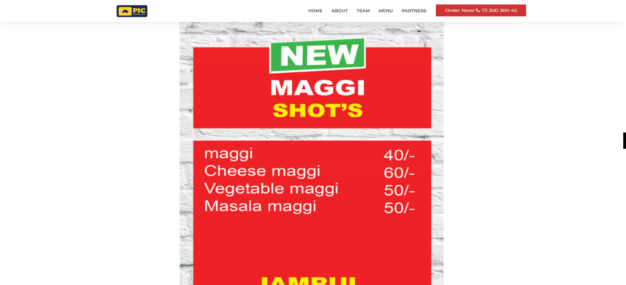

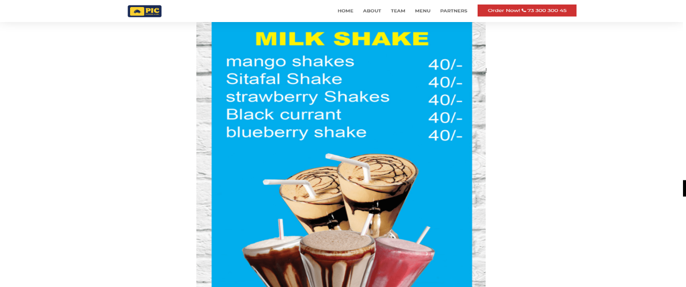

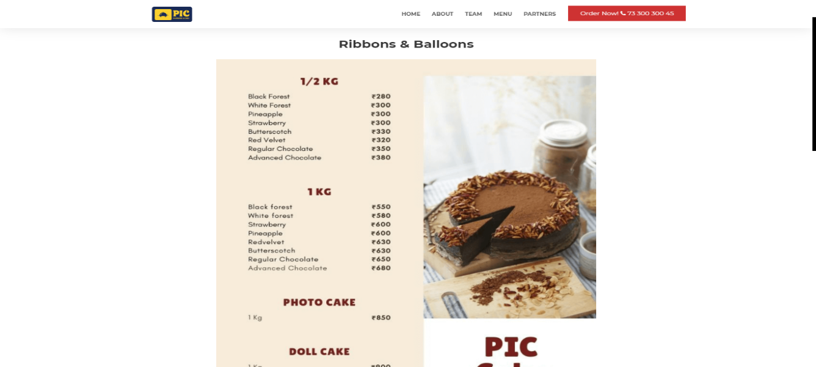

**DEPLOY AND PUSH OF CODE USING GIT**

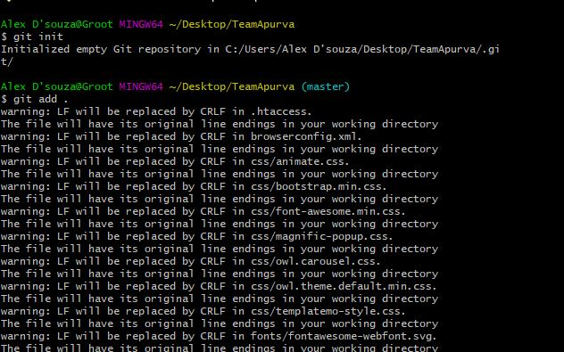

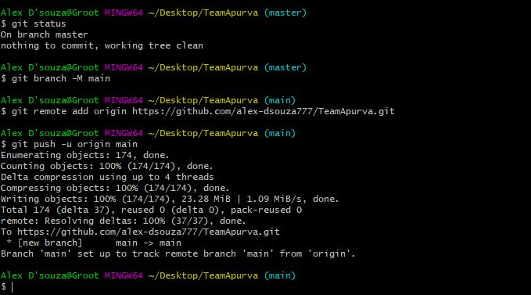

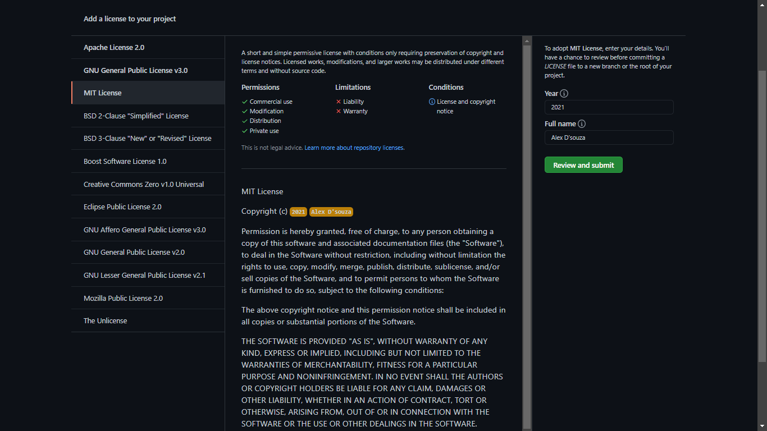

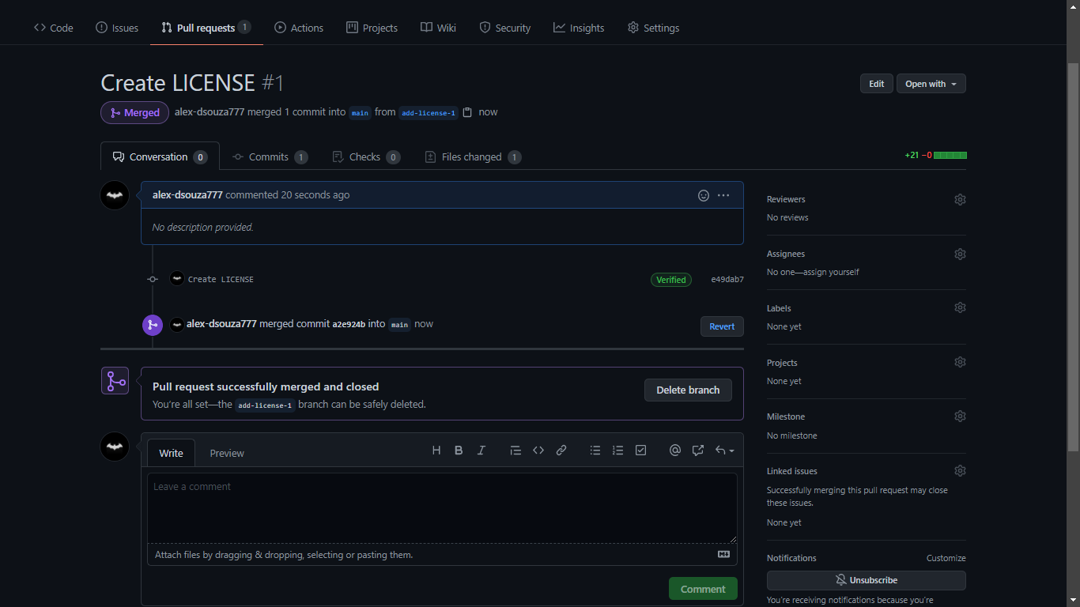

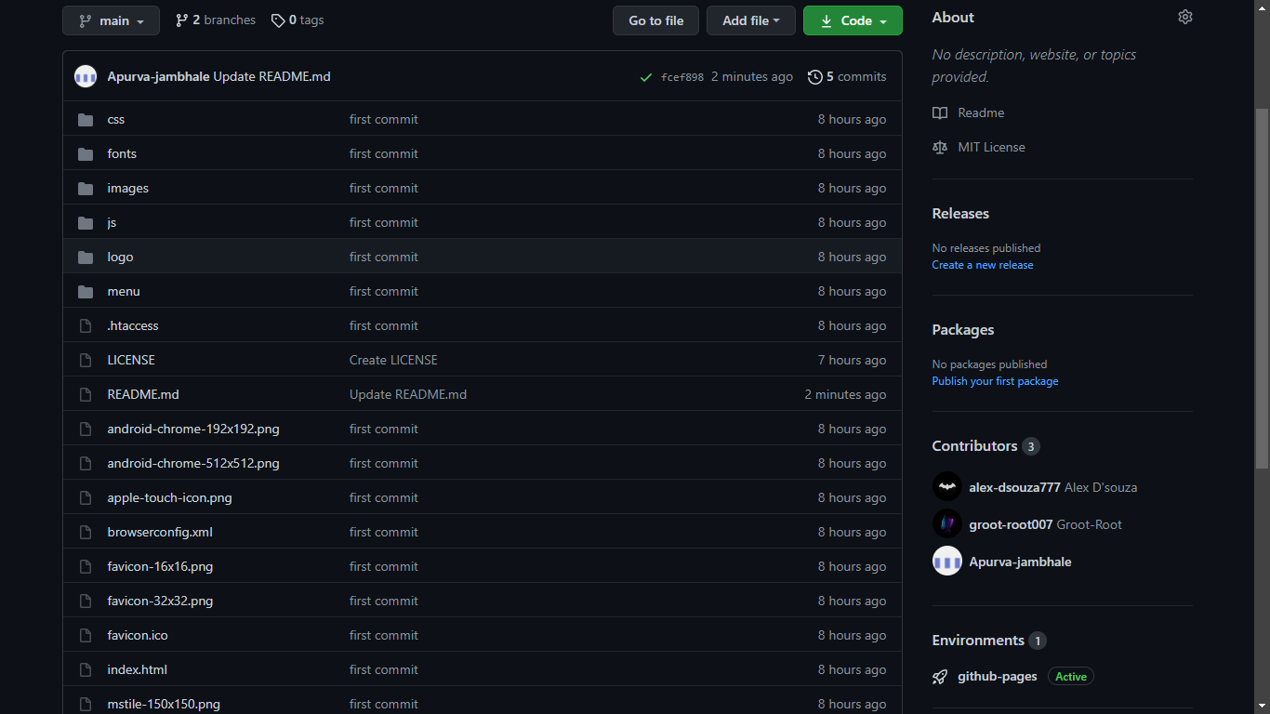

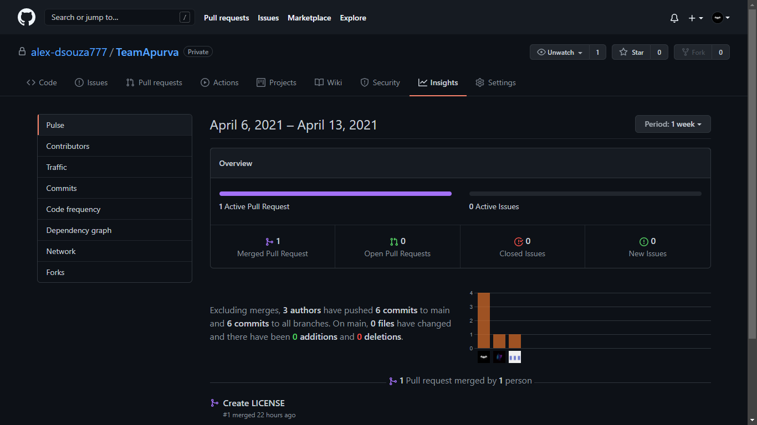

**CONCLUSION**

The Conclusion of the system is based on user’s need and is user centered. The system is developed in considering all issues related to all user which are included in this system. Wide range of people can use this if they know how to operate android smart phone. Various issues related to Mess/Tiffin Service will be solved by providing them a full fledged system. Thus, implementation of Online Food Ordering system is done to help and solve one of the important problems of people. Based on the result of this research, it can be concluded: It helps customer in making order easily; It gives information needed in making order to customer. With online food ordering system, a restaurant and mess menu online can be set up and the customers can easily place order. Having a

restaurant menu on internet, potential customers can easily access it and place order at their convenience. Thus, an automated food ordering system is presented with features of feedback and wireless communication.

**FUTURE ENHANCEMENT**

Allow customers to customise orders and reservation system.

Allow online payment and save details.

Allow to process order as guest.

Allow to find and choose nearby restaurant.

This order food online system project aimed at developing an online food ordering system which can be used in small places, and medium cities firstly and then on a large scale.

It is developed to help restaurants to simplify their daily operational and managerial task as well as improve the dining experience of customers.

And also helps restaurants develop healthy customer relationships by providing good services.

**Bibliography**

1. [**https://www.w3schools.com/bootstrap4/bootstrap_get_started.asp**](https://www.w3schools.com/bootstrap4/bootstrap_get_started.asp)
2. [**https://getbootstrap.com/docs/5.0/getting-started/introduction/**](https://getbootstrap.com/docs/5.0/getting-started/introduction/)
3. [**https://www.w3schools.com/css/**](https://www.w3schools.com/css/)
4. [**https://github.com/**](https://github.com/)